EXPERIMENT 11: TOR

AIM

To understand how the Tor network works and how to access anonymous websites securely.

PROCEDURE

- Study the concept of the Tor network and anonymity.
- Set up and connect to the Tor network (e.g., using Tor Browser or Tails OS).
- Access and explore .onion (dark web) websites.
- Understand how Tor routes traffic through multiple nodes for privacy.

QUESTIONS

TASK 1 - TOR Browser

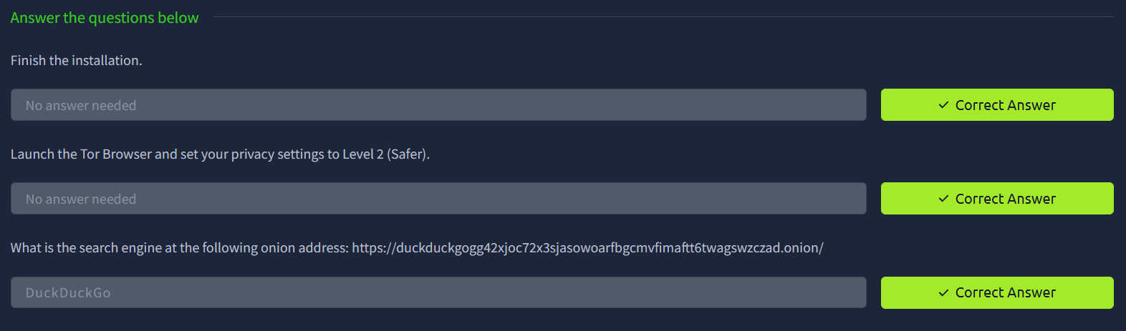

RESULT

Learned how Tor provides anonymity and how to safely access and explore hidden services on the network.

